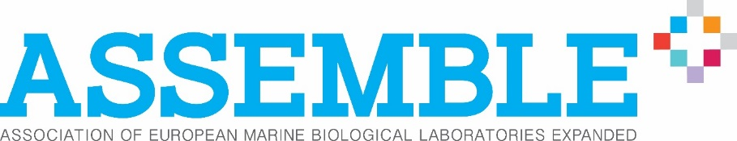

New funding call provides researchers with
free access to marine biological stations

The EU-funded ASSEMBLE Plus project (www.assembleplus.eu) is pleased to announce its fourth call for access to many of Europe’s key marine biological stations, but this time it’s a little different:
to simplify the process for applicants, this call will remain open until October 2021.
Requests for physical access will be evaluated on specified cut-off-dates and remote access will be reviewed on a rolling basis.

ASSEMBLE Plus’ popular funding mechanism provides researchers with effective and convenient access to some of Europe’s cutting-edge research infrastructures. Designed for scientists from academia, industry and policy, the mechanism provides support to researchers who wish to gain access – on-site or remote – to more than 30 marine installations, or “Access Providers”.

In less than 18 months, more than 150 projects have been granted access through the ASSEMBLE Plus’ transnational access programme. Many success stories are being reported. One such story comes from Andrea Waeschenbach from the Natural History Museum in the United Kingdom, who was granted the opportunity to join R/V Oceania at the Institute of Oceanology of the Polish Academy of Sciences (IOPAN) in Poland:

"My experience aboard the Research Vessel Oceania was outstanding. Our host, Dr Piotr Kuklinski, provided great expertise in collecting and identifying Arctic bryozoans [enabling us to incorporate rare species into our molecular phylogenetic framework]; took care of all the logistics; and, provided all necessary equipment and chemicals. Furthermore, the onboard scientific facilities and living quarters were excellent. Overall, a well-organised and successful trip!"

The available opportunities range from on-site access to ecosystems or experimental facilities to remote access to biological resources or data. The application process is simple, and successful proposals will be given access at no cost. Visits can last for up to 30 days and can include up to two persons per project. ASSEMBLE Plus will covers the cost of travel, accommodation and meals.

Online submission will open on 20th May 2019. Click here to download and print the call flyer.

For more information on the call, including eligibility and how to apply, visit www.assembleplus.eu/access/transnational-access. For specific requests, please contact the Access Officer (assembleplus_ta@embrc.eu). For press queries, please contact the ASSEMBLE Plus Project Manager, Clément Brousse (clement.brousse@sorbonne-universite.fr)

Applicants are encouraged to contact the Access Provider to explore the feasibility of the proposal. Applications will be peer-reviewed by external experts. Accepted projects should be performed within six months from the date of its acceptance. Expensive consumables may incur a charge and limits may be placed on travel and subsistence costs. Marine installations (access providers) available through the Transnational access programme of ASSEMBLE Plus.

